**Use Case: Admin Dashboard**

**Actor:** Admin

**Use Case Description:** This use case outlines the process for an admin to utilize the dashboard in the procurement web application. After logging in, the admin is directed to the dashboard, which presents key metrics and visualizations related to procurement activities. The dashboard includes cards displaying information about purchase requisitions, purchase orders, invoice count, and total requests for quotation (RFQs). Additionally, there are panels for spend analysis, requisition stats, purchase orders, top suppliers, and monthly expenses, each providing insights into different aspects of procurement.

**Trigger Point:** The trigger point occurs when the admin logs into the procurement web application and is directed to the dashboard interface.

**Pre-conditions:**

1. The admin has valid credentials to access the procurement web application.

2. The procurement web application is operational and accessible.

3. The admin has appropriate permissions to view and interact with the dashboard.

4. Relevant data related to purchase requisitions, purchase orders, invoices, RFQs, spend analysis, requisition stats, purchase orders, top suppliers, and monthly expenses are available in the system.

**Post-conditions:**

1. The admin successfully accesses the dashboard and gains insights into procurement activities.

2. Any actions taken by the admin based on the dashboard information are accurately recorded and reflected in the system.

**Normal Flow:**

1. The admin opens a web browser and navigates to the URL of the procurement web application.

2. The system prompts the admin to enter their credentials (username and password) to log in.

3. Upon successful authentication, the system redirects the admin to the dashboard interface.

4. The admin views the dashboard, which consists of:

* Four cards representing purchase requisitions, purchase orders, invoice count, and total RFQs.

* A spend analysis panel displaying top spending categories with a horizontal bar graph. With the drop button

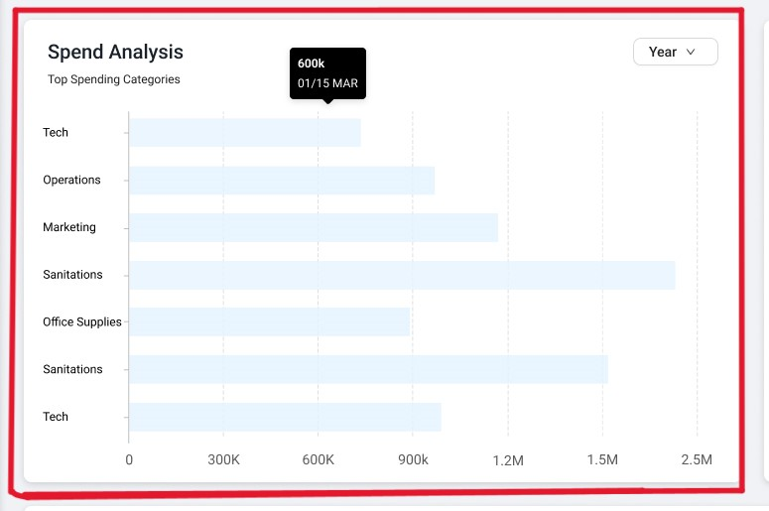

* A requisition stats panel showing the distribution of approved, rejected, pending, and on-hold requisitions using a doughnut chart. The admin can toggle between different months using the "month" button.

* A purchase order panel presenting a line graph depicting the status of active, approved, and settled purchase orders.

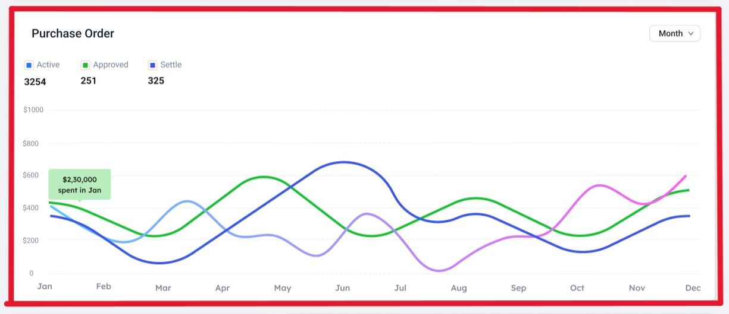

* A top suppliers panel listing supplier names along with their total orders and total amounts.

* A Top Request panel featuring a vertical bar graph, with the ability to switch between different years using the "Month" button

5. The admin reviews the data and visualizations presented on the dashboard to gain insights into procurement activities, spend patterns, requisition status, purchase orders, top suppliers, and monthly expenses.

6. Based on the insights gained, the admin may initiate further actions, such as approving pending requisitions, analysing spend trends, or reviewing supplier performance.

**Alternative Flow:**

1. If the admin encounters difficulties accessing the dashboard or viewing data, they may refresh the page or try logging in again.

2. In cases where the data displayed on the dashboard appears inaccurate or incomplete, the admin may need to investigate and troubleshoot the underlying issues within the procurement system.

3. If the admin needs to perform advanced analyses or access additional data beyond what is provided on the dashboard, they may utilize reporting or analytics tools integrated into the procurement web application.